**Breast Cancer Classification using Machine Learning**

**Abstract**

Breast cancer is one of the leading causes of death among women worldwide. Early detection and accurate classification of tumors as benign or malignant are crucial for effective treatment. This project uses a supervised machine learning approach — specifically **Logistic Regression** — to classify breast tumors using the **Wisconsin Breast Cancer Dataset**. Furthermore, we incorporate **SHAP (SHapley Additive exPlanations)** to interpret the model's decisions and highlight the key features influencing predictions.

Project Link: [Breast Cancer Classification using Machine Learning](https://colab.research.google.com/drive/1xQzHJD-2yxIU-w-bkokPZOxYeQw5gVC8?usp=sharing)

**Problem Statement**

Traditional diagnostic methods for breast cancer can be time-consuming, error-prone, and often lack transparency. The need exists for an automated, accurate, and interpretable system that can:

* Classify tumors as benign or malignant.
* Provide insight into **why** the model makes a particular decision (for trust and accountability in clinical settings).

**Proposed Solution**

This project builds a Logistic Regression model to predict tumor classes and enhances model transparency using SHAP. The solution includes:

* Clean and prepare clinical data.
* Train a machine learning classifier.
* Evaluate performance metrics.
* Apply **SHAP** for global and local explainability.

**Dataset Description**

* **Source**: [Breast Cancer Wisconsin (Diagnostic) Data Set](https://www.kaggle.com/datasets/uciml/breast-cancer-wisconsin-data)
* **Instances**: 569
* **Features**: 30 numerical features + 1 target column (label)
* **Target Classes**:
  + 0 → Malignant
  + 1 → Benign

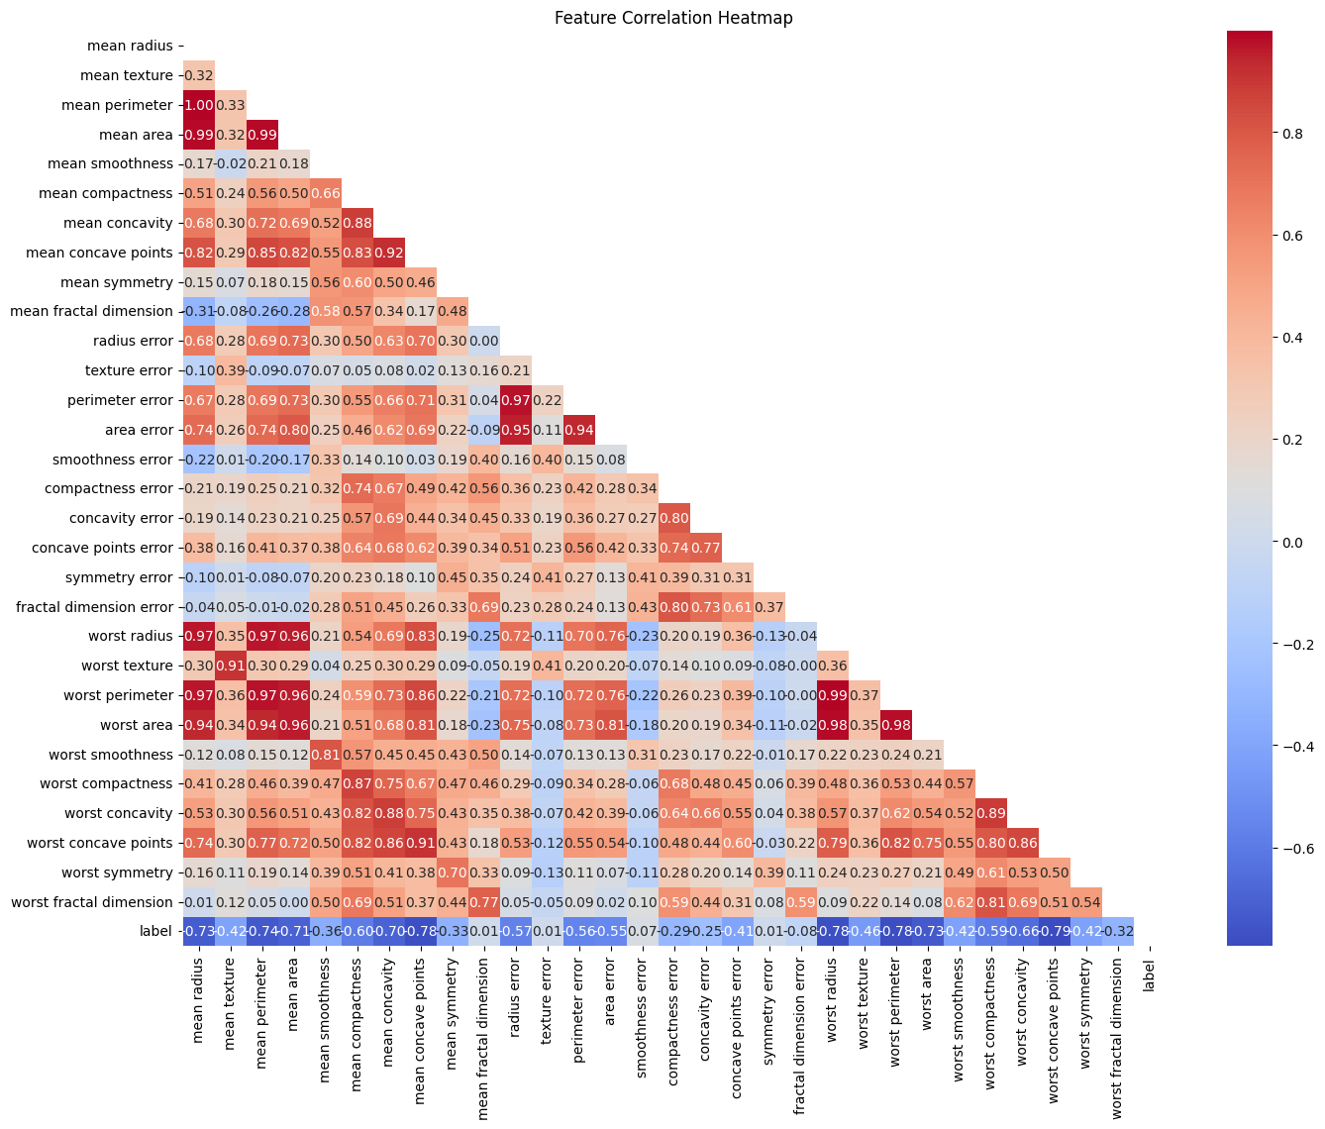

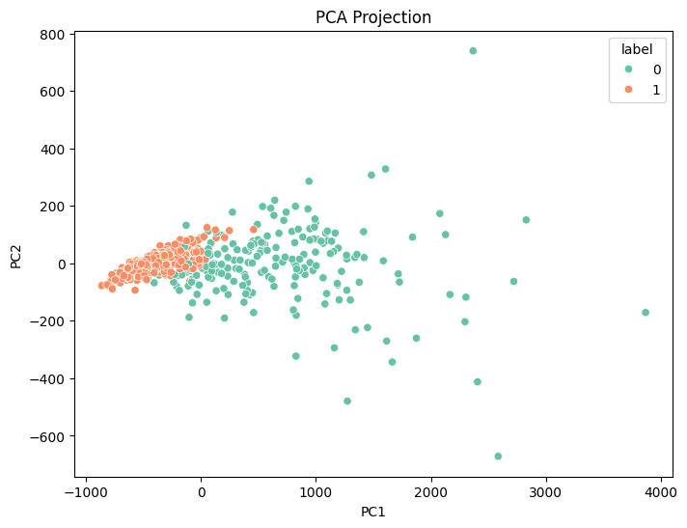

**Technologies Used**

* **Language**: Python
* **Libraries**:
  + scikit-learn (modeling & preprocessing)
  + matplotlib, seaborn (visualization)
  + SHAP (model explainability)
  + NumPy, Pandas (data handling)
* **Environment**: Google Colab

**Methodology**

**Data Loading & Exploration**

* Loaded the dataset from sklearn.datasets.
* Converted to Pandas DataFrame.
* Checked data structure, types, and class imbalance.

**Preprocessing**

* Target column label was added.
* No missing values found.
* Split into **X** (features) and **Y** (labels).
* Train-test split: 80% training / 20% testing.

**Model Training**

* Used **Logistic Regression** due to its interpretability and performance.
* Achieved:
  + **Training Accuracy**: ~94.9%
  + **Testing Accuracy**: ~92.9%

**Prediction**

* Provided functionality to classify new input data (30 features) into:
  + **Malignant** (0)
  + **Benign** (1)

**Model Evaluation**

* **Confusion Matrix** shows correct classification of most test samples.

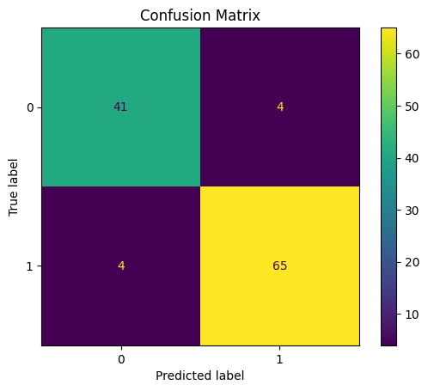

* **Accuracy**, **Precision**, **Recall**, and **F1-score** were within acceptable thresholds.

**Model Explainability with SHAP**

**Why SHAP?**

* Makes **black-box models interpretable**.
* Useful in healthcare for **transparency and fairness**.

**Insights from SHAP:**

* **Top influencing features**:
  + mean perimeter, worst perimeter, mean area, worst radius, worst area.
* SHAP summary plots showed:
  + High values of certain features push prediction toward **malignant**.
  + Low values push toward **benign**.

**Visualizations Used:**

* SHAP Summary Plot

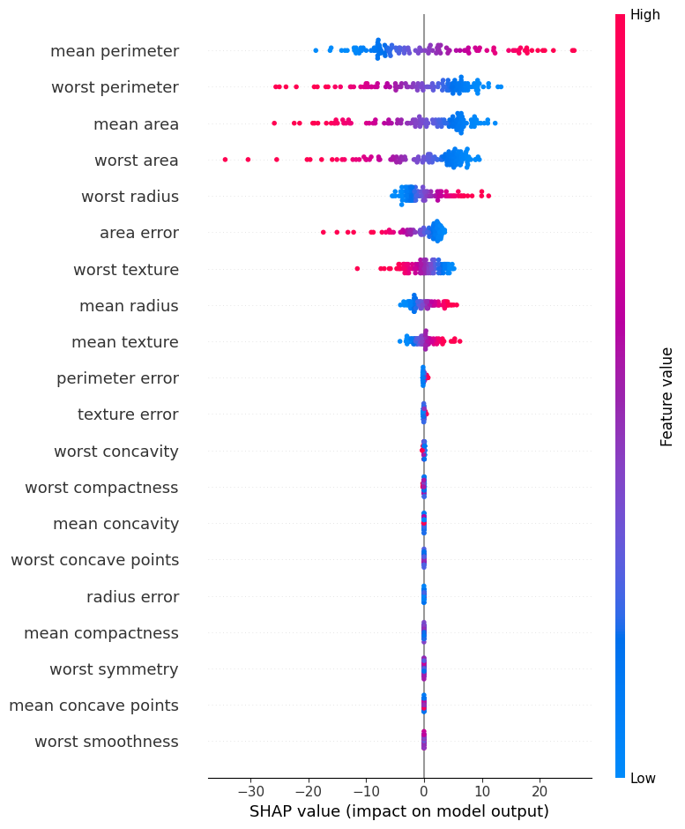

**Sample Input Prediction**

input_data = (17.2, 15.8, 110.0, 910.2, 0.1023, 0.1304, 0.1505, 0.0894, 0.1901, 0.0623,

0.4201, 1.250, 3.150, 30.21, 0.00955, 0.0201, 0.0359, 0.01501, 0.0212, 0.0032,

18.8, 21.5, 120.7, 1100.0, 0.155, 0.2301, 0.3205, 0.175, 0.3152, 0.0895)

**Prediction**: "The Breast cancer is Malignant"

**Conclusion**

This project successfully demonstrates a **lightweight, interpretable, and high-performing** machine learning approach to breast cancer diagnosis. Integrating SHAP improves **trust and understanding**, making it suitable for real-world healthcare applications where explainability is essential.